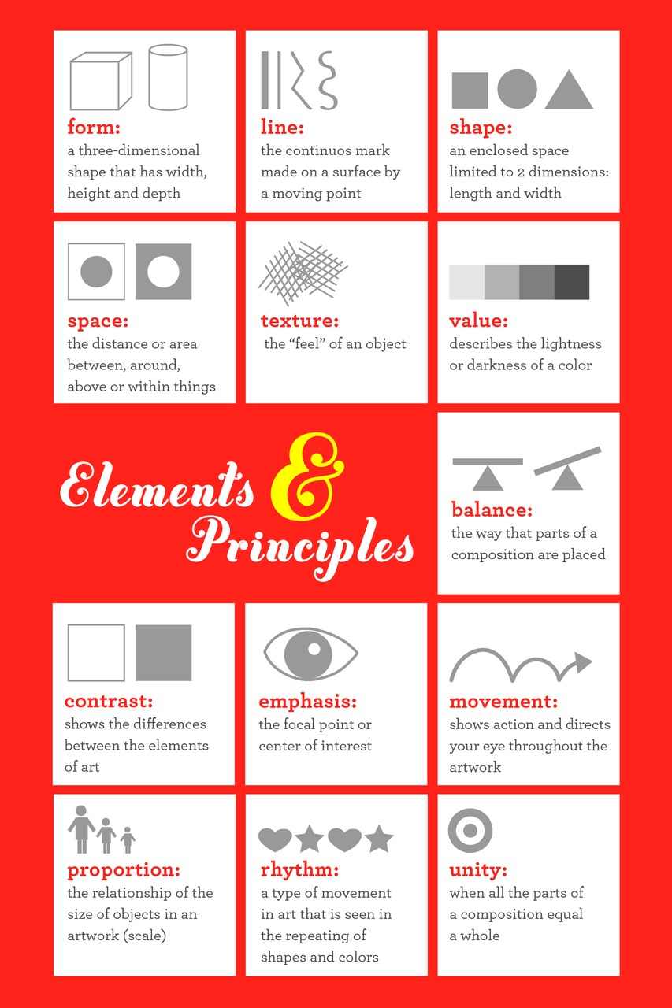

http://mrsagresti.tumblr.com/image/1215755475